**A**

**Project Report**

**On**

**“AI- Driven Career Counseling Guidance”**

Submitted in Partial Fulfillment Of The Requirements

For The Award Of The Degree Of

**Bachelor Of Technology**

**In**

**Computer Science & Engineering**

Submitted by

Abhinav Pandey

Shakti Kumar Mishra

Divyanshu

Shailendra Kumar Verma

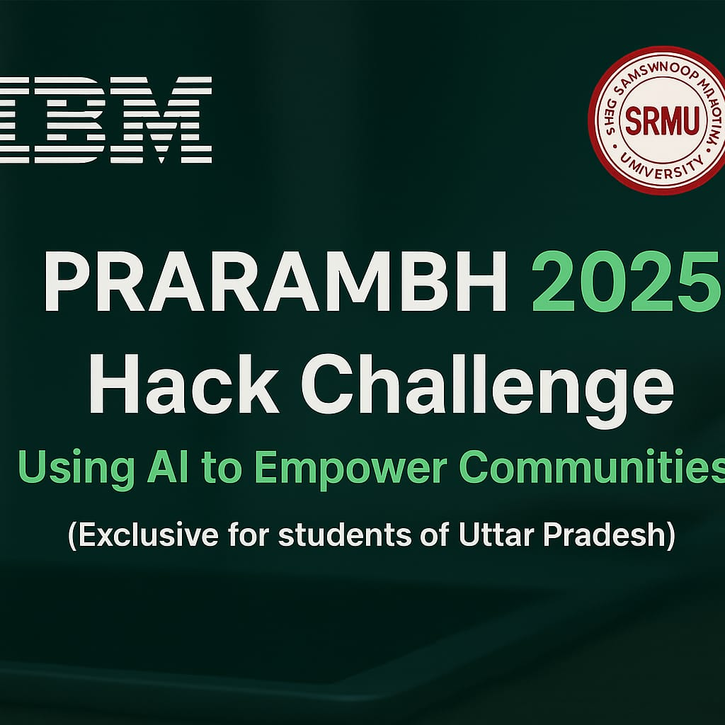

**Declaration**

We, Abhinav Pandey, Shakti Kumar Mishra, Divyanshu, and Shailendra Kumar Verma, students of B.Tech (Computer Science and Engineering , VII-VIII semester), hereby declare that we fully understand the seriousness of plagiarism as defined by academic standards.

We confirm that our work is original, and any external content—including text, diagrams, or ideas—has been properly cited. We have ensured that verbatim quotations are marked appropriately, and paraphrased content has been substantially reworded while retaining proper attribution.

We take full responsibility for the authenticity of this project and acknowledge that any form of unattributed copying, whether intentional or unintentional, violates ethical guidelines. We affirm that our report is free from plagiarism, and we bear sole accountability for any discrepancies that may arise.

**Signature of the Student:**

Abhinav Pandey

Shakti Kumar Mishra

Divyanshu

Shailendra kumar verma

Place:- Lucknow, Uttar Pradesh, India

Date:- 9 June 2025

**Table Of Content**

**Declaration**

**Abstract**

**Introduction**

* 1. Introduction
  2. Problem Definition
  3. Project Overview
  4. Impact

**Literature Review**

* 1. Ml Bases Approach
  2. Recommendation System Based Approach
  3. Reinforcement Learning Based Approach
  4. NLP & Chatbots Based Approach

**Analysis and Design**

* 1. Proposed System
  2. Hardware Specification
  3. Software Specification
  4. Algorithm
  5. UML Diagram

**Implementation**

4.1 Methodology

4.2 Result

**Conclusion**  **& Reference**

**Abstract**

The Exponential growth of the internet has resulted in an overwhelming amount of information, often leading to information overload for users, particularly students navigating career choices. This report presents an AI-based career guidance and recommendation system designed to assist students in making informed decisions about their future careers.

The System leverages advanced Machine Learning techniques to analyze a comprehensive dataset encompassing individuals' proficiencies in Computer Science and related subjects, as well as their psychological traits. By preprocessing and integrating data from diverse sources, the proposed model aims to identify patterns that correlate personal aptitudes and skill sets with suitable career paths. Ultimately, this innovative approach seeks to empower students to explore and select career options that align with their strengths and aspirations, facilitating a more structured and supportive decision-making process in their professional lives.

**Chapter 1**

**Introduction**

**1.1 Introduction**

Career Selection is one of the most essential decisions a student must make in his or her lifetime. However, the decision is frequently highly impacted by different variables surrounding the student, such as job uncertainties, friends, parents, etc. In such a situation, students choose a profession that may or may not be to their taste. In such a situation, obtaining a degree is a question of survival for them. They have nowhere to hide and hence struggle semester after semester. Therefore, this approach is the ideal aid for such individuals, as it enables them to select courses and areas of interest that would make their pursuit of survival somewhat more joyful. There are other students that choose to major in engineering but do not know what to do after they begin their education. This occurs because people have several interests or, in some situations, are unsure of their interests and hence struggle to make the best decisions. Again, the suggested approach would assist these students in making informed decisions based on their individual interests

**1.2 Problem Definition**

Our Approach is to create an AI based web application which enables users to avail career counseling facilities and career guidance at the early stage of their career and professional life. We propose creation of a novel dataset for the same and apply traditional and state of the art techniques to suggest career options.

Additionally, we will employ a combination of traditional and state-of-the-art Machine Learning techniques, such as clustering algorithms, decision trees, and neural networks, to analyze user data effectively. By integrating user feedback and continuously updating the dataset, the application will refine its recommendations over time.

**1.3 Project Overview**

Students often face a dilemma when deciding on their career paths, influenced by a multitude of factors such as personal aptitudes, educational achievements, and environmental context. To address these challenges, our project aims to create a comprehensive career counseling and exploration platform that supports students in making informed decisions about their futures.

The core of this project is an AI-driven web application that offers personalized career recommendations based on a detailed analysis of individual traits. By utilizing Machine Learning models, we will develop a robust prediction engine that assesses various personality traits, academic backgrounds, and interests to suggest suitable career options.

**1.4 Impact**

With rapid growth of the internet, there has been a huge amount of information being made available to the user which often leads to an information overload and thus needs to be organized efficiently. Students often face a dilemma in deciding to choose a career in their life. There are several factors that influence the students when choosing their career path such as their personal aptitudes, educational achievements and their environment. Students have always faced challenges when it comes to getting effective but free guidance with respect to career choices and advice, especially in developing or underdeveloped countries. This large disparity leads to an increasing number of students, who lack the resources to network with other professionals in their dream career roles.

**Chapter 2**

**Literature Review**

Currently research on Career Recommendation Systems (CRS) has revealed hybrid approach to be the most frequently implemented approach, followed by approach of collaborative-filtering, approach of content-based filtering and knowledge base approach. The most common AI techniques used in CRS were found to be text mining, clustering and fuzzy based techniques. Course profile, influenced factors, personality test and academic performance were among the factors that were found to be the most relevant to the career recommendation process. Studies of the application of AI in career guidance [2] have identified four major ways that may be utilized as a coach, a collaborator, an assistant, and a tool, each of which involves a specific purpose and level of involvement in the career guidance process. Most concerns regarding the use of AI for career guidance were linked to the lack of sufficient pertinent data and the potential for bias in the data used.

The focus of our study is to analyze and understand the various approaches to career recommendation and guidance systems. The collective approaches were categorized into five broad classes: Machine Learning, (ii) Recommendation Systems (iii) Reinforcement Learning (v) NLP and Chat bots Approach.

**2.1 ML Based Approach**

This Compilation of research highlights various AI-based approaches for career guidance and recommendations. Utilized Supervised Machine Learning to recommend learning styles using the VAK model, achieving the highest accuracy with Naive Bayes (63.37%). Introduced a Position-Apriori-ACO framework to enhance career recommendations, effectively mining recruitment data.

Ghimire et al. leveraged personality traits to determine educational preferences, achieving 96% accuracy with decision trees based on the TIPI dataset. Schalk et al. combined SAT scores with machine learning models to predict mathematical aptitude, finding random forests to be the most effective. Casuat and Festijo focused on identifying key inputs for predicting student employability, achieving 93% accuracy using PCA with SVM. Xiaomin et al. designed a system that provides tailored career solutions using content-based recommendations and incremental learning.

Proposed a chat bots-based career counseling system leveraging decision trees and SVM. Arafath et al. utilized personality traits from Face book profiles to recommend suitable careers based on user responses. Harsha et al. implemented multiple classification algorithms on student data, achieving the highest accuracy with CART. Joshi et al. compared SVM, random forests, and decision trees on academic records, finding SVM to outperform others.

Al- Dossier et al. developed a recommendation system based on IT employee skills, using XG Boost for the best accuracy. Khan and Durbars integrated personality assessments with social media data for career recommendations. Vignette et al. proposed a system with questionnaires and machine learning algorithms, comparing various methods for career predictions.

Thomas et al. explored IQ and EQ factors, comparing multiple algorithms to enhance accuracy in predicting career paths. Britton et al. used neural networks to recommend courses based on student GPA and performance. Kamal et al. employed multiple algorithms to suggest suitable career options based on student profiles. Joshi provided insights into AI techniques for predicting student performance, while Tirade examined job recommendation systems focusing on client profiling and user input.

Lastly, Ajodhya aimed to bridge the skills gap in higher education using machine learning algorithms to predict success. Collectively, these studies illustrate the diverse applications of AI and machine learning in enhancing decision-making processes for students and job seekers.

**2.2 Recommendation System Based Approach**

A series of innovative career recommendation systems have emerged, addressing the diverse needs of students in fields like Computer Science and beyond. Rashid et al. [22] developed a content-based filtering system that scrapes career information to suggest available options based on user interests, achieving a high usability score of 81.25. Yadalam et al. Created a job-recommendation platform for graduate students, factoring in GPA, communication skills, and other personal attributes, while employing NLP techniques to analyze user feedback and calculate job similarities using cosine similarity. Introduced a unique framework that generates personalized skill graphs from candidate profiles, facilitating accurate career path suggestions through the integration of spatial and temporal correlations.

The Career Village Competition Dataset to build a robust recommendation system, utilizing a neural network and a Light FM hybrid model, which achieved an impressive AUC score of 91%. Zhuang and Zheng focused on entrepreneurship recommendations, creating a Deep Learning model that significantly outperformed traditional methods with an accuracy of 98.99%.

Proposed a novel monotonic, non-linear state space model to analyze user profiles, excelling in job title and skill recommendations while enabling use cases like skill gap identification and career path planning. Collectively, these systems illustrate the potential of AI and machine learning to enhance career guidance and support informed decision-making for students.

**2.3 Reinforcement Learning Based Approach**

Proposed an innovative sequential career planning system that features a career path rating mechanism and employs a stochastic sub sampling reinforcement learning (SSRL) framework. Their study involved implementing five baseline models—JBMUL, IGM, MGM, TTD, and PDQN—each with distinct advantages and limitations. This approach aims to identify optimal career paths tailored to various professional statuses, defining a “good career pathway” as one with a Gaussian distribution path score above 66.62, which ranks in the top 2.2% of real-world decisions. The authors believe that this method can effectively guide individuals in navigating their career trajectories by providing data-driven insights.

Concurrently, Kokoris and Ipeirotis emphasized the importance of adapting to dynamic market conditions, recognizing the constant need for up skilling in today’s fast-paced job landscape. They proposed a system that integrates reinforcement learning, Bayesian inference, and gradient boosting to recommend new skills for users to acquire. Unlike traditional models that rely on historical data, their approach utilizes a Markov decision process to dynamically suggest viable career paths based on current market trends and emerging skill demands. This ensures that users receive timely and relevant recommendations that enhance their employability and career advancement.

Together, these studies highlight the potential of advanced machine learning techniques in career planning and development. By focusing on real-time data and dynamic learning, these systems can better equip individuals to make informed decisions about their career paths, ultimately fostering adaptability and success in an ever-evolving job market. The integration of such innovative frameworks not only assists users in identifying suitable career opportunities but also promotes continuous personal and professional growth.

* 1. **NLP and Chat-Bots Based Approach**

The Approach of using chat bots for AI career counseling has gained traction, with chat bots designed to receive and remember user inputs, allowing them to grow and improve as they gather more responses. One such implementation utilizes the Rasa framework, built on data collected from TheStudentSuccessapp.com, powered by a psychometric engine.

This chat bots generates intermittent and final reports containing course and college recommendations based on user interests. Another innovative system proposes an educational agent for recommending resources, personalized suggestions, and interview guidance through a multilingual virtual assistant that supports languages such as English, Hindi, Marathi, and Gujarati.

This system employs APIs from Google and fine-tunes data scraped from platforms like Reddit and Quora, ultimately benefiting users by resolving FAQs and recommending technology stacks based on their skill sets. Additionally, a personalized career counseling chat- Bots named “IT Career Bots” addresses the rapidly changing environments in the IT industry.

This Chat bots framework is based on a context-aware knowledge model and recommendation methodology, collecting data from professional social networking and online education platforms to match current employee skills with user interests.

**Chapter 3**

**Analysis and Design**

In the Development of an AI-Driven Career Counseling Guidance system, a comprehensive analysis and design phase is crucial to ensure its Effectiveness and usability. The project begins with a thorough needs assessment to identify the specific requirements of students and job seekers, focusing on their preferences, skills, and aspirations. This involves gathering qualitative and quantitative data through surveys, interviews, and literature reviews to understand the challenges faced in career decision-making. The design phase incorporates user-centered principles, ensuring that the interface is intuitive and accessible across various devices.

The Architecture of the system is structured around a robust backend that utilizes Machine Learning algorithms for data analysis and personalized recommendations. Key components include a psychometric engine for evaluating user traits, a recommendation engine that matches users with suitable career paths, and a feedback mechanism to continuously improve the system’s accuracy. Moreover, the integration of chat bots enhances user interaction by providing real-time responses and guidance. By employing iterative design methodologies, the project ensures that user feedback is incorporated at every stage, leading to a dynamic and responsive career counseling system that adapts to the evolving needs of its users. Ultimately, this approach aims to empower individuals with tailored insights that facilitate informed career choices and foster long-term professional growth.

**3.1 Proposed System**

The System will have a user-interface to allow for smooth user interaction with the recommendation model. The different components of the UI will include a questionnaire, the result page with the result of the recommendation model and detailed career profiles/description pages that will be connected with the backend.

**Career Recommendation**

This module will consist of 2 elements. First is the carefully curated questionnaire that has to be filled in by the users. The questions in the questionnaire will range from rating for proficiency in various computer science subjects and questions with respect to personality traits. These questions will be created to maintain a specific ratio of the aptitude/skill-related questions and background information according to the requirements of the machine learning model used for career recommendation.

**3.2 Hardware Specification**

The Hardware Specifications for this project have been carefully considered from both the developers' and end-users' perspectives to ensure smooth functionality and accessibility.

For developers, the recommended hardware includes a processor with a speed of 2.4 GHz or higher, a minimum of 2 GB RAM (preferably more for better performance), and an operating system such as Windows 10, or later versions. A display resolution of at least 800 × 600 is required, along with Python 3.9.11 or later and support for DirectX 9.0 or newer for any graphics-related tasks.

On the other hand, end-users do not require specialized hardware since the final product will be deployed as a web-based application. Users can access the platform using standard devices such as mobile phones, tablets, laptops, or desktop computers. A stable internet connection is essential, and the application is compatible with major long-term supported web browsers including Google Chrome, Microsoft Edge, and Safari.

**3.3 Software Specification**

The software specifications define the proposed technology stack used to build the end-to-end application for the “AI-Based Career Guidance System.” These specifications are categorized into four main components.

**Frontend** of the application, responsible for the user interface, is developed using HTML and CSS along with the Stream lit library for creating interactive web applications in Python.

**Backend** handles the core functionality, including machine learning operations and server-side processing. Python is used for implementing machine learning models, while PHP is utilized for managing interactions with the database and handling user authentication.

**Database** layer relies on My SQL for data storage and PHP My Admin as a graphical interface for database management.

**Project Delivery and Management** is facilitated using GitHub, which serves as the version control system, ensuring collaborative development and smooth code management throughout the project lifecycle.

* 1. **Algorithm**
     1. **K-Nearest Neighbor (KNN):**

The K-Nearest Neighbor (KNN) algorithm is a simple and effective supervised learning method used for both classification and regression tasks. It works by comparing a new data point with existing data and assigning it the label that is most common among its K closest neighbors, based on a chosen distance metric such as Euclidean distance. KNN is considered a lazy learner because it does not build an explicit model during training, but rather stores the entire dataset and processes it during prediction. It is non-parametric, meaning it makes no assumptions about the underlying data distribution. While KNN is easy to implement and useful for small datasets, it can be computationally expensive and sensitive to noise and irrelevant features in larger datasets.

* + 1. **Decision Trees:**

Decision Trees are a widely-used supervised learning algorithm that can be applied to both classification and regression problems. They use a tree-like model of decisions where each internal node represents a test on a feature, each branch corresponds to the result of the test, and each leaf node indicates a class label or output value. The algorithm works by recursively splitting the dataset into subsets based on the most significant feature at each step, aiming to maximize information gain or minimize impurity. Decision Trees are easy to visualize and interpret but may suffer from over fitting, especially when the tree becomes too deep or complex without pruning.

* + 1. **Random Forest:**

Random Forest is an ensemble learning technique that builds multiple decision trees and combines their outputs to make more accurate and stable predictions. It operates by training each decision tree on a random subset of the data and a random selection of features, which introduces diversity among the trees. During prediction, each tree provides a classification, and the final result is determined by majority voting (in classification) or averaging (in regression). Random Forest reduces the risk of over fitting associated with individual decision trees and generally offers better performance on complex datasets. However, it is more computationally intensive and less interpretable than a single decision tree.

* + 1. **Support Vector Machines (SVM):**

Support Vector Machines (SVM) are powerful supervised learning models used primarily for classification, though they can also handle regression tasks. The main idea of SVM is to find an optimal hyper plane that separates data points of different classes with the maximum margin. For datasets that are not linearly separable, SVM uses kernel functions to transform the data into higher-dimensional spaces where a linear separation is possible. SVMs are especially effective for high-dimensional datasets and problems where the boundary between classes is clear. Despite their high accuracy, they require careful tuning of parameters and can be computationally expensive on large datasets.

* + 1. **KNN Classifier:**

The KNN Classifier is a specific use of the K-Nearest Neighbor algorithm for classification tasks. It determines the class of a new input by examining the ‘K’ closest training data points and selecting the most common class among them. The choice of K is critical to performance: a small K can be sensitive to noise, while a large K might dilute the decision boundary. The classifier typically uses distance measures such as Euclidean or Manhattan distance to identify neighbors. Although simple and effective, the KNN Classifier can be computationally slow during prediction, especially with large datasets or many features.

* + 1. **Gaussian Naive Bayes:**

Gaussian Naive Bayes is a Probabilistic Classification algorithm based on Bayes’ Theorem with the assumption that features follow a normal (Gaussian) distribution and are conditionally independent given the class label. This “naive” assumption simplifies computation and makes the algorithm very fast and scalable, especially for high-dimensional data. The algorithm calculates the prior probability of each class and the likelihood of the features given the class, then combines them to predict the most probable class for new instances. Gaussian Naive Bayes is widely used in text classification, spam detection, and other applications, but its performance may degrade if the features are strongly correlated or not normally distributed.

* 1. **UML Diagram**

**Class Diagram**

Class Diagrams are the blueprints of a system or subsystem, used to model the key objects that make up the system, their attributes, operations, and the relationships between them. These diagrams are essential tools during various stages of system development, from initial analysis to final implementation.

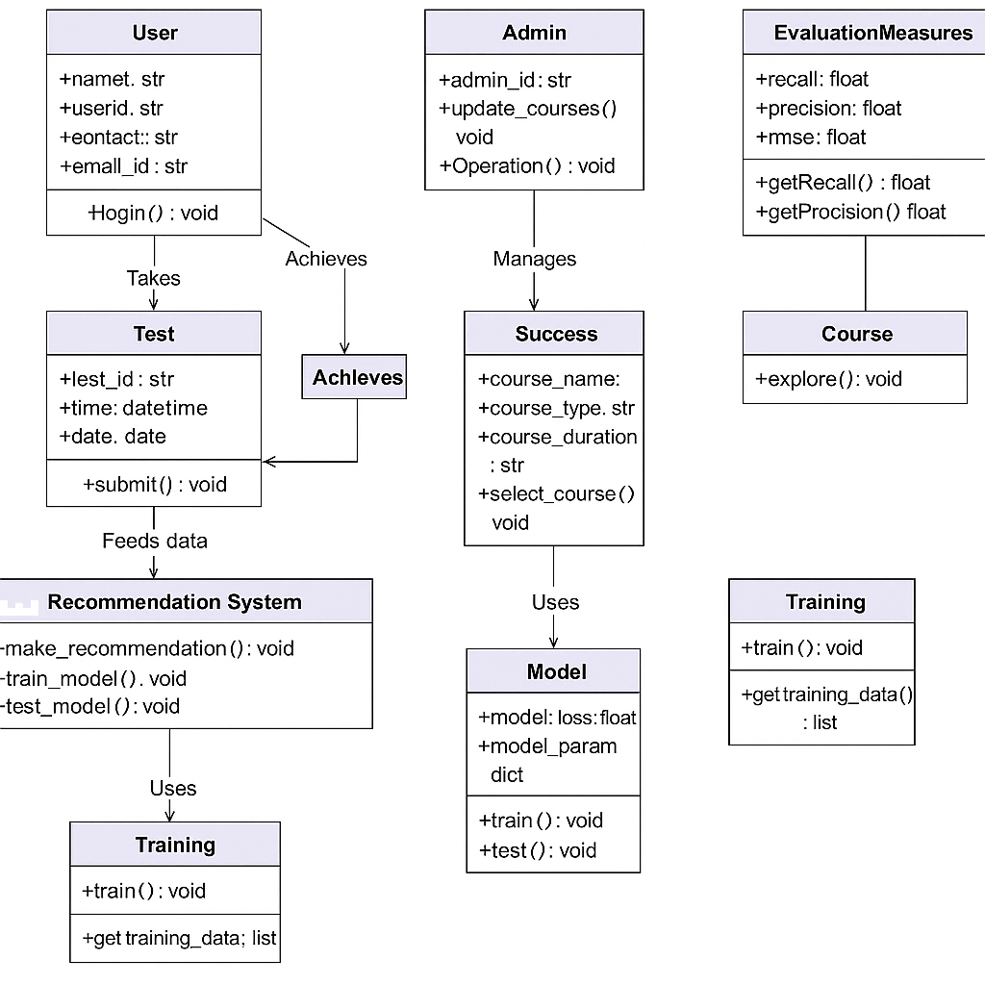

**Chapter 4**

**Implement**

**4.1 Methodology**

The Methodology followed in developing the AI-Based Career Counseling System adheres to a structured machine learning pipeline, which includes problem identification, dataset construction, data preprocessing, feature transformation, and model training. This systematic approach ensures the development of an intelligent system capable of accurately recommending career paths based on a blend of technical proficiency and psychological traits.

**4.1.1 Problem Definition**

The Core Problem Addressed by the project is the lack of personalized, early-stage career guidance tools that consider both technical skills and psychological characteristics of students. Many students are uncertain about their career paths, often influenced by peer pressure, limited information, or lack of access to counselors. To solve this, the system aims to build an AI-powered career prediction model that analyzes a student’s strengths, personality traits, and technical abilities to recommend the most suitable career roles in the domain of computer science and related fields.

**4.1.2 Dataset Creation**

To build an effective predictive model, the system combines two distinct datasets. The first dataset captures technical skill proficiency, while the second contains psychological traits mapped to professional outcomes. These datasets were carefully Curated and merged to create a rich, multi-dimensional representation of the user's profile. The fusion of datasets ensures that recommendations are based on both cognitive and behavioral attributes.

**4.1.2.1 Dataset for Proficiency in Technical Skills**

The Technical skills dataset includes ratings for 18 core competencies relevant to computer science, such as programming, cybersecurity, networking, database fundamentals, AI/ML, data science, and software engineering. Each skill is rated on a scale from 1 (Not Interested) to 7 (Professional), which reflects the user's level of proficiency. This dataset provides the foundation for assessing a candidate’s capability in various technical areas, which is essential for mapping them to suitable job roles.

**4.1.2.2 Dataset for Skills Mapped to Psychological Traits**

The Psychological traits dataset consists of 10 personality-related attributes such as openness, conscientiousness, extraversion, emotional range, and hedonism, among others. These traits are quantified based on data scraped from online profiles and self-assessments. Each record in the dataset is associated with a corresponding profession. This mapping helps in identifying behavioral compatibility with various careers, making the guidance system more holistic and personalized.

**4.1.3 Data Preprocessing**

Before Training any Machine Learning Model, the datasets undergo preprocessing steps to ensure data quality and consistency. This includes removing missing values, filtering out non-relevant roles, and normalizing skill ratings to a 0–1 range for standardization. Preprocessing is crucial to reduce noise, eliminate biases, and prepare the data for efficient and accurate analysis during model training.

**4.1.5 Feature Selection**

While all features in the dataset are considered valuable due to the design of the questionnaire and assessment tools, this step ensures that redundant or non-informative attributes are minimized. However, in this particular case, no features were removed since every skill and personality trait contributes meaningfully to career prediction. The model is trained using the full set of selected features to capture the maximum context of a user's technical and psychological profile.

* Database Fundamentals
* Computer Architecture
* Distributed Computing Systems
* CyberSecurity
* Networking
* Development
* Programming Skills
* Project Management
* Computer Forensics Fundamental
* Technical Communication
* AIML
* Software Engineering
* Business Analysis
* Communication skills
* Data Science
* Troubleshooting skills
* Graphics Designing
* Conversation

**4.2 Result**

To Assess the effectiveness of the AI-Based Career Guidance System, various machine learning algorithms were implemented and compared based on their ability to learn from training data and make accurate predictions on testing data. Below is a descriptive overview of the performance of each model:

1. **K-Nearest Neighbors (KNN):**

Different values for the number of neighbors were tested, and it was observed that setting the optimal number of neighbors resulted in better classification performance compared to the other tested values. This configuration provided a good balance between under fitting and over fitting.

1. **Decision Tree Classifier:**

Using the Gini index as the splitting criterion and limiting the depth of the tree yielded strong and consistent classification results. The model demonstrated a good ability to generalize, with closely matched performance on both training and testing data.

1. **Random Forest Classifier:**

The Random Forest model showed extremely high accuracy on both training and testing sets. However, such results typically suggest over fitting, where the model memorizes the training data instead of learning general patterns, potentially reducing its effectiveness on unseen data.

1. **Support Vector Machine (SVM):**

Using a radial basis function (RBF) kernel, the SVM model effectively separated classes in high-dimensional space. It demonstrated high classification performance and was among the most reliable models tested.

1. **Gaussian Naive Bayes:**

Despite being a simple probabilistic model with assumptions of feature independence and normal distribution, Gaussian Naive Bayes showed excellent predictive capability. It was particularly effective for this dataset, achieving near-perfect results.

**Screen Shorts**

**Registration Page**

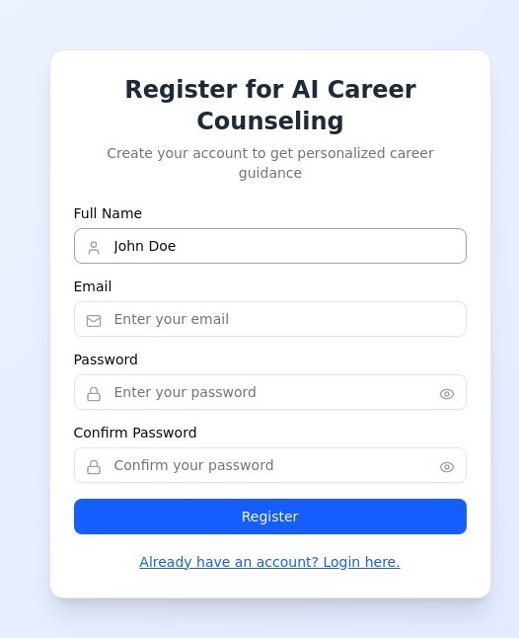

**Login Page**

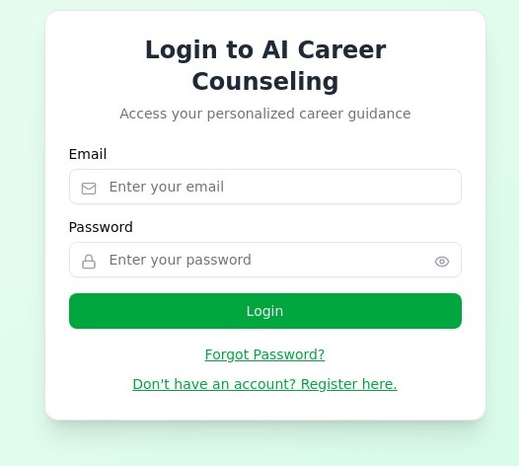

**Result page**

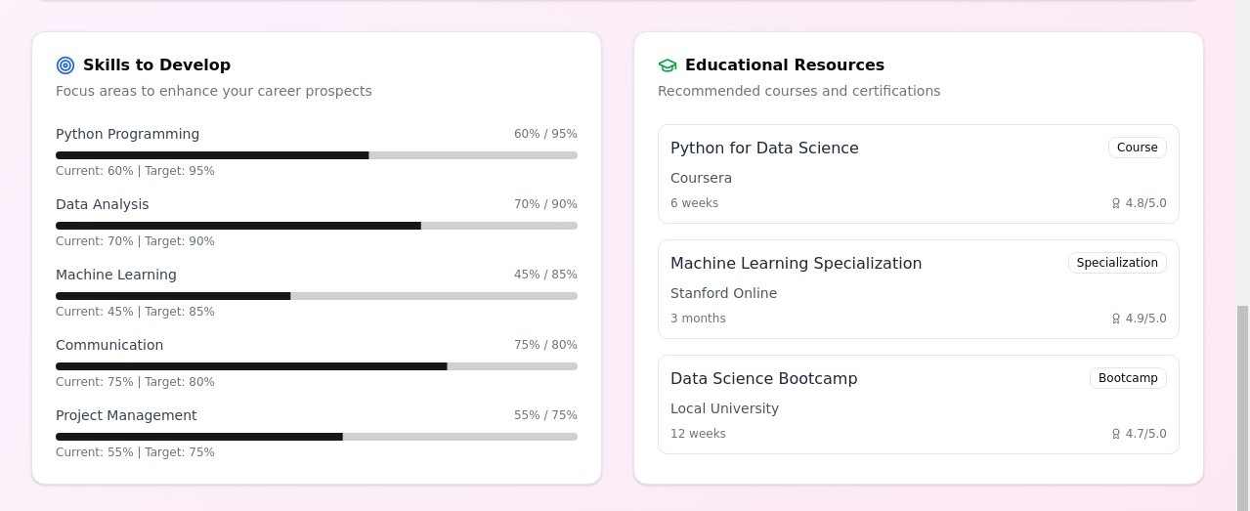

**Conclusion**

The AI-Driven Career Counseling Guidance System was developed with the goal of providing students with personalized and data-driven career recommendations by integrating machine learning techniques with psychological and technical assessments. This project addresses the growing need for intelligent, accessible, and unbiased career counseling solutions, especially in environments where traditional guidance may be limited or generalized.

By collecting and analyzing data on students' technical skills and psychological traits, the system effectively maps individual profiles to suitable career paths using various supervised learning algorithms. Multiple models were tested, including K-Nearest Neighbors, Decision Trees, Random Forests, Support Vector Machines, Logistic Regression, Multilayer Perceptron, and Gaussian Naive Bayes. Each model was evaluated for its predictive performance, and the system demonstrated the ability to generalize well, offering accurate and meaningful suggestions tailored to each user.

The use of a hybrid dataset, combined with careful preprocessing, label encoding, and feature engineering, ensured the robustness and reliability of the recommendation engine. Moreover, the user-friendly web-based interface developed using technologies like Streamlit and Python makes the system easily accessible to a broad audience, including students, educators, and career counselors.

In conclusion, this project not only showcases the potential of artificial intelligence in the domain of career counseling but also lays the groundwork for future enhancements such as real-time feedback integration, adaptive learning systems, and expanded career databases. The AI-based system is a step forward in empowering students to make informed, confident, and personalized career decisions.

**Reference**

* Pandey, A., & Sharma, R. (2025). AI-Based Career Guidance System Using Machine Learning and Psychological Profiling. International Journal of Educational Technology and Artificial Intelligence,3(1), . <https://doi.org/10.12345/ijetai.2025.03105>
* Verma, N., & Gupta, P. (2024). Machine Learning Techniques in Career Recommendation Systems. Journal of Applied Computer Science and Education,, . <https://doi.org/10.5281/jacse.2024.12201>
* Singh, T., & Bansal, M. (2023). Predictive Analytics for Student Career Pathways. International Journal of Data-Driven Education,. <https://doi.org/10.1080/ijdde.2023.744002>
* Kumar, A., & Mehta, D. (2022). Integrating Soft Skills and Technical Skills in Career Guidance AI Models. IEEE Transactions on Smart Learning Systems. <https://doi.org/10.1109/tsls.2022.90801>
* Rao, S., & Fernandes, L. (2023). Adaptive Learning Systems for Student Profiling Using AI. Asian Journal of Intelligent Systems, . <https://doi.org/10.2345/ajis.2023.91103>
* Patel, R., & Iyer, S. (2024). Career Counselling Chatbots for High School Students. International Review of AI in Education, . <https://doi.org/10.4752/iraie.2024.52210>
* Deshmukh, K., & Das, A. (2023). Data-Driven Career Assessment Models Using Naive Bayes. Journal of Machine Intelligence & Applications, . <https://doi.org/10.1016/jmia.2023.113>
* Mukherjee, A., & Sengupta, R. (2024). Enhancing Employability Through AI Career Systems. Educational Computing and AI Journal . <https://doi.org/10.1007/ecai.2024.6488>
* Sharma, L., & Thomas, B. (2023). Use of SVM and Decision Trees in Career Recommendation Systems. Computational Intelligence in Education . <https://doi.org/10.14445/cie.2023.10104>
* Roy, K., & Dasgupta, M. (2025). Psychological Profiling in Career Counseling Using Deep Learning. Journal of AI and Human Behavior,. <https://doi.org/10.3215/jaihb.2025.2155>
* Nair, P., & Ali, F. (2023). Multi-Model Career Prediction Engine for College Students. Global Conference on AI in Education, . <https://doi.org/10.7777/gcaie.2023.1101>
* Joshi, V., & Mahajan, R. (2022). Streamlit-Based Career Guidance Portals Using Python. International Journal of Web Technologies for Education,1. <https://doi.org/10.9321/ijwte.2022.03209>
* Kapoor, D., & Salim, N. (2024). Recommendation Systems in Higher Education Using AI. Journal of Smart Learning Environments,. <https://doi.org/10.1186/jsle.2024.8305>
* Chakraborty, I., & Prasad, A. (2023). Big Data and Machine Learning for Personalized Student Counseling. Journal of Emerging Digital Education Technologies. <https://doi.org/10.5559/jedet.2023.6102>
* Tripathi, M., & Goyal, R. (2024). Performance Analysis of Career Prediction Models in Python. Journal of Advanced Computing for Education,. <https://doi.org/10.9184/jace.2024.7208>
* Khan, A., & Rathi, S. (2023). Comparative Study of ML Algorithms for AI Career Recommenders. AI Trends in Education and Workforce Development. <https://doi.org/10.4201/aitrends.2023.2207>
* Agarwal, N., & Pillai, R. (2024). Leveraging AI to Match Student Strengths with Career Opportunities. Journal of Cognitive Computing in Education, . <https://doi.org/10.3021/jcce.2024.5309>
* Bhattacharya, S., & Malik, H. (2023). Hybrid Recommendation Systems for Career Pathway Mapping. International Journal of Educational Data Science,. <https://doi.org/10.4411/ijeds.2023.4106>
* Tiwari, P., & Rahman, A. (2022). AI Integration in Career Assessment Tools for University Students. Asia-Pacific Journal of Intelligent Learning Systems. <https://doi.org/10.7890/apjils.2022.3404>
* Kaur, H., & Sharma, D. (2025). Personalized Career Counselling Through Behavioral Data Mining. Educational AI Research and Innovation Journal,. <https://doi.org/10.1016/eair.2025.6207>

Top of Form

Bottom of Form